 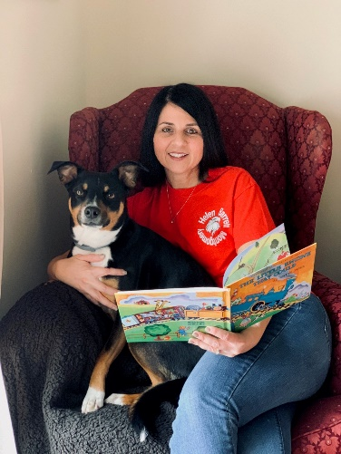

**Dear Families,**

I would like to take this opportunity to introduce myself to you. My name is **Jolene Mezzio** and I will be having the great opportunity to work with you and your child this school year. Although I may be new to some of you, some of your children and I are very familiar with each other as I see them in the hallway.

I have an open door policy, PLEASE feel free to ask any questions and I will do my very best to find the answers. I will be setting up a Seesaw Account; this is the main source of our communication and where daily assignments and ***homework*** will be posted.

**NOW WHO AM I?** Well, I am happy to say that I attended # 7 School, Virgil I Grissom, from Kindergarten through 7th grade. I have been teaching at RCSD my entire 24 years of teaching. I have taught mostly in Kindergarten and Grade 1, but I have taught Grade 5, I have been an Instructional Coach for the District supporting our teachers, and an Intervention Teacher working with students who need additional support in reading.

I am married to my husband, Rob, and we have 2 daughters. My oldest is Adrianna and she is 21 studying accounting in college. Our younger daughter is Francesca and she is 16 and a junior in high school. We also have a crazy dog named Rosie, who brings us much happiness throughout the day! I love spring and summer; I love to plant, cook, and just be outdoors. If it were not for my family, I would have moved south to warmer weather!

I am very excited to get to know all of you, so please take the time to email me at [Jolene.mezzio@rcsdk12.org](mailto:Jolene.mezzio@rcsdk12.org) and introduce you and your child. I am very excited to work with all of you this year.

**Thanks for all your support-**

**Jolene C. Mezzio** [jolene.mezzio@rcsdk12.org](mailto:jolene.mezzio@rcsdk12.org)

**IMPORTANT: Parents/Guardians** if you have a change or addition to contact information

- New cell

- New home phone

- Adding a new adult to contact

- Email address

- Other information

**Please contact Ms. Jewell Brown** our Parent Liaison **Cell 585- 953-2508** [**jewell.brown@rcsdk12.org**](mailto:jewell.brown@rcsdk12.org)

*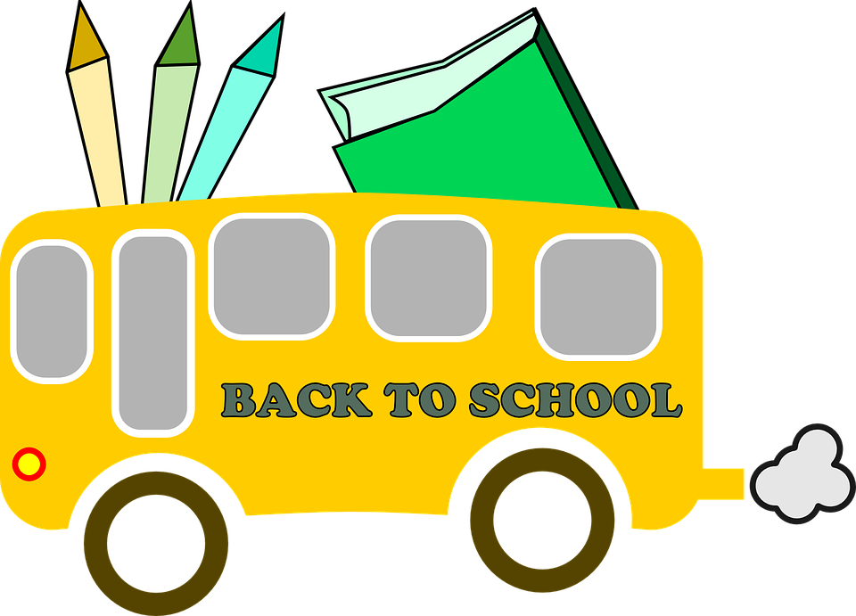WELCOME TO FIRST GRADE!*

*School Supply List 2022*

**Supplies needed for in school:**

* 2 boxes of 24 count Crayola crayons ***(label with your child’s name)***
* Glue sticks (pack of 4)
* Kid’s Fiskar Scissors (blunt tip)
* Pencil box (8x5 in.) ***(label with your child’s name)***
* Dry erase Expo markers (pack of 4)
* 1 hard covered composition notebook ***(label with your child’s name)***
* 2 Box of tissues
* 1 box of 12 pencils (sharpened)
* 1 pump bottle of hand sanitizer(8 oz. labeled)
* 1 container of Lysol or Clorox wipes**(or a cleaning product)**
* 1 pair of headphones (Please NO earbuds) We can no longer share the headphones. **(*Please send them labeled in a clear plastic ziplock bag with your child’s name on the bad/headphones)***
* 2 folders with 2 pockets on the bottom (your child’s choice) ***Please write your child’s name on the folders.***

**Supplies needed at home (for homework):**

**Crayons, Scissors, Gluestick, & Pencils**

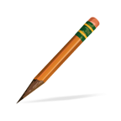  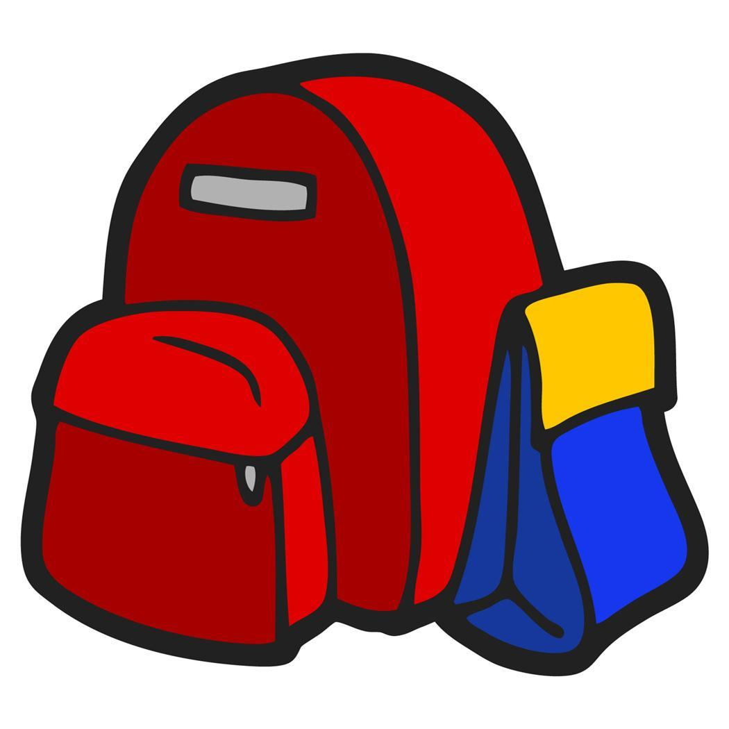

**Thank you-**

**Grade 1 Team**